*Staphylococcus* and Other Pathogenic Bacteria found on the Cellphone Screens of Both Students and Professors on a University Campus

Shreya Barma

November 19, 2019

# Introduction

When the phone was first introduced to society, its sole purpose was to be able to communicate with others. Today, with the evolution to the cellphone, the role of the typical phone has drastically expanded from its intended use, to call or to text someone. It’s now used as a GPS device, to browse the internet, play games, listen to music, and much more (Lonkila and Gladarev, 2008). Due to all of these new applications and the evolution of the traditional phone, cellphones are being used almost all day, everyday by their owners. This daily use and the benefits provided by a cellphone, causes individuals to overlook cellphone hygiene, or even consider the large amount of bacteria that accumulates on the screen of their phones.

Studies have been done in clinical settings, showing how healthcare professionals use their cellphones throughout the day, both before and after assessing patients. This resulted in a significant transfer of bacteria, since most cellphone users, healthcare workers included, do not clean their cellphone screens. Especially in a medical setting, this can cause more diseases and more infection. Healthcare workers have been found to transmit nosocomial infections via their medical equipment and mobile phones (Kumar and Aswathy, 2014). This puts not only cellphone users at risk, but the patients, the health care workers and their families as well.

However, healthcare workers are not the only ones with phones carrying bacteria, studies have shown that with a general cellphone user, there is 10x more bacteria on a cellphone screen than a toilet seat (Akinyemi *et al.*, 2009). Aside from clinical settings, I aimed to focus on a school setting, and to see whether cellphones used by students and professors also carried pathogenic bacteria. Middle school students’cellphones have been found to have a median of 17,032 bacterial 16S rRNA gene copies per phone. Additionally,out of the number of bacteria found on these phones, a significant number were found to be potentially pathogenic. These bacteria included *E. faecalis* and many more (Chawla *et al.*, 2009).There is an extremely large amount of pathogens on cellphones of secondary school students, with over 94.5% of cellphones demonstrating evidence of bacterial contamination (Ulger *et al.*, 2009).

Another study conducted by the Department of Microbiology at Lagos State University focused on the actual spread of bacterial infections through the use of cellphones. Through this study they found a high percentage (62.0%) of bacterial infection being spread solely through cellphones and the lack of cleaning this technology (Akinyemi *et al.*, 2009). This shows the significance of the bacterial presence on cellphones. I wanted to find out the relevance of this issue in a school setting, and whether or not pathogens would still be found on cellphones outside of clinical settings.

The purpose of my project was to show the importance of hygeine with an individual’s technology, especially cellphones since we carry them around everywhere on a daily basis. My project focuses on identifying the type and amount bacteria on the cell phone screens of students at the University of San Francisco compared to those found on the cellphone screens of professors. This is to see whether or not phones carry potential pathogens, which are disease-causing bacteria, outside of a clinical setting. Thus, this experiment can help build a correlation between how illnesses are spread on college campuses and technology usage.I will specifically focus on the presence of *Escherichia coli*, *Staphylococcus*, and *Pseudomonas* as they are a few of the most common pathogens found on cellphones (Lee *et al.*, 2013).

These bacteria are known to cause serious infections. *Staphylococcus* for example, is a dangerous pathogen. This bacteria is known to cause endovascular disorders, bone and joint disorders, respiratory issues, as well as skin disorders. The mortality rate ranges from 11 to 43 percent (Lowy, 1998). *E.coli* is a bacteria that normally is found in the human intestine as well as other animals. is transmitted through contamination of food, such a raw meats, or through the contact with fecal matter.

My questions for this project were: Do cellphones really carry potential pathogens? Do students have a higher amount of bacteria on their cellphones compared to professors? My hypothesis is that all cellphones will carry potential pathogens. Student cellphones will have a significantly higher amount of potential pathogens compared to professor cellphones.

To test this hypothesis, I gathered a total of 6 samples using a sterile swab dipped in phosphate buffer solution. 3 of these samples were from different students and the remaining 3 samples were collected different professors. Once my samples were collected, I diluted each sample with PBS to 1x, 10x, and 100x and then cultured these samples on an agar dish. After incubation, I used PCR to amplify the DNA samples and gel electrophoresis to separate the DNA fragments. I, also, used Qubit to quantify DNA concentrations. Finally, Sanger sequencing was used to sequence my DNA samples. With these successful results, I used BLAST to run my samples against the NCBI database and figure out what strains my were.

With this project, I concluded that student cellphone screens had a larger amount of colonies, as predicted. However, the number of morphotypes found was higher on professors’ cellphone screens. Through this experiment, *E.coli* and *Pseudomonas* were not detected on any of the cellphone screens for neither students or professors. However, two different types of *Staphylococcus* were detected. Another bacteria which was not expected to be found, *Kocuria palustris*, was detected.

## Methods

### Sampling

Materials needed for this project include sterile phosphate buffer solution (PBS), 12 1.5mL tubes, and sterile swabs. For this project, I collected a total of twelve samples, two samples per cellphone. Therefore, I swabbed a total of six phones, three from each sample group. To collect my samples, I used a sterile swab dipped in the buffer solution. I swabbed the entire front screen of each phone for 30 seconds and then stored the swab in a sterile tube. Once I finished collecting all my samples, I broke off the portion of the swab with my sample on it into separate tubes and labeled them accordingly.

### Culturing & DNA Extraction

After sampling, each sample was diluted to 1x, 10x, and 100x using PBS solution, and then cultured. These were the cultured samples. I used 18 100 mm TSA plates for plating samples from each of my 2 treatments (n = 3 per group, 6 total). Then, I pipetted 100 μL of each sample onto a 100 mm TSA plate and used rattler beads to spread the sample evenly across the TSA plate (Leung *et al.*, 1995). Once I plated my samples, they were incubated for 4 days and then analyzed for the number of morphotypes present and the amount of colonies.

For DNA extraction, I followed the manufacturer’s protocol from the Sigma REDExtract-N-Amp Kit (Kreader *et al.*, 2001). From my TSA plate, I scraped samples from the most secluded colonies, trying to avoid colonies that were in contact with one another to try to avoid contamination. After this, I pipetted  
198 μL of the Qubit solution and 2 μL of my DNA extraction into a Qubit tube. After placing the Qubit solution and my sample in the Qubit tube, I vortexed this mixture for 5 seconds and incubated the tubes in the dark for 5 minutes. Once this was complete, I used the Qubit to analyze the amount of DNA successfully extracted.

### PCR, Gel Electrophoresis, and Sequencing

Two rounds of PCR and gel electrophoresis were conducted for this experiment. One round was with a PCR done with cultured samples, which were the 1x, 10x, and 100x dilutions, and the second round was done with culture free samples.

For both types of samples, the formula to make the master mix for the PCR reaction was: (n+1)+10%, where n is the number of samples I have, which in this case is six.

For the PCR with the cultured samples, the master mix included 77 μL of Amp, 6.2 μL of the 27f primer, 6.2 μL of 1492r primer, 7.7 μL of BSA, and 49.28mL of PCR water. For each alloquat, I added 19 μL of the master mix and 1 μL of the specific DNA template. For each alloquat, I added 19 μL of the master mix and 1 μL of the specific DNA template (Korbie and Mattick, 2008).

These tubes were then taken into the thermocycler by Professor Zimmerman and set to run at the following temperatures: 95°C for 5 minutes, 94°C for 30 seconds, 65°C for 30 seconds, 72°C for 1 minute, 94°C for 30 seconds, 55°C for 30 seconds, 72°C for 1 minute, 72°C for 10 minutes, and then finally placed on a 4°C hold.

This set of samples was then sent for Sanger sequencing. After checking for successful amplification using gel electrophoresis, PCR products were cleaned with ExoSAP (Invitrogen) and sent for unidirectional Sanger sequencing at MCLAB located in South San Francisco, CA (Kreader *et al.*, 2001).

For the PCR with the culture-free samples, the master mix included 77 μL of Amp, 6.2 μL 10 μM iseq 16sF primer, 6.2 μL 10 μM iseq 16sR primer, 7.7 μL BSA, and 49.3 mL of PCR water. For each alloquat, I added 19 μL of the master mix and 1 μL of the specific DNA template.

These tubes were then taken into the thermocycler by Professor Zimmerman and set to run at the following temperatures: 95°C for 3 minutes, 95°C for 30 seconds, 55°C for 30 seconds, 72°C for 30 seconds, 72°C for 5 minutes, and then placed on a 4°C hold. This set of samples were then sent for illumina sequencing.

Following electrophoresis, PCR products were purified using AmpureXP magnetic beads (Meyer and Kircher, 2010) and quantitated using a PicoGreen fluorescent assay (Invitrogen) on a Tecan Infinite M Plex plate reader. Purified PCR products were used as the template for a second round of PCR, which served to attach unique pairs of forward and reverse Illumina barcodes (Nextera XT Index 2 kit). All other components of the PCR mixtures were as for the first-round PCR. These reactions were cycled at 95 degrees C for 3 minutes, then 8 cycles of: 95°C for 30 s, 55°C for 30s, and 72°C for 30s, followed by a 5 minute elongation cycle at 72°C. Following this amplification, PCR products were purified and normalized with a SequelPrep normalization plate (Invitrogen), pooled, and then quantified once again with a Qubit 4 fluorometer (Invitrogen) and a TapeStation 4200 (Agilent) to verify library size and concentration. This library was then diluted to the loading concentration (50 pM) and combined with an Illumina PhiX spike-in library (5% spike in) and sequenced on an Illumina iSeq using a 2 x 150 bp consumable cartridge.

The gel for the PCR was a standard 1% agarose gel and was prepared ahead of time by Professor Zimmerman. To prepare the gel, 1g of agarose is measured and mixed with 100mL of 1xTAE buffer in a microwaveable flask. This flask is then microwaved for 1-3 minutes until the agarose powder is completely dissolved. Then the agarose and buffer mixture is allowed to cool to the point where it is comfortable to hold the flask. It is then poured into the gel tray with the well comb already set in place. Once poured, the tray with the agarose gel is set out to cool for around 10 minutes or until fully hardened.

Once the thermocycling was complete, the gel was carefully loaded with 2-20 μL pipettes and then run on the electrode for 30 minutes.

### Sequence Analysis

After receiving all of my data from Sanger sequencing, I used Geneious to analyze and trim my samples and build phylogenies based off of my sequences. I trimmed the ends of my sequences, any low quality sequences, and used the IUPAC ambiguity codes to rename bases. Once the sequences from all of my samples were trimmed, I used the NCBI website’s BLAST tool to determine what strains of bacteria were found on the cellphone screens I swabbed and infer the function of my sample sequences from similar sequences found in the archive (Madden, 2013). Using BLAST, I chose the results that were not unspecified, and had a high percentage match. Of the 3 samples that failed, I marked these files as failed sequences and did not use them for this project. I used MAFFT to create a multiple alignment sequence (Katoh and Standley, 2013). The setup for Mr.Bayes included having the substitution model as GTR, rate variation as invgamma,and outgroup set as *Thermus aquaticus*. The MCMC settings for chain length was set to 1,100,000, heated chains was set to 4, heated chain temp was set to 0.2, subsampling freq set to 200, the burn-in length set to 100,000, and the random seed length was set to 10,736. The rest of the settings were on default (Kearse *et al.*, 2012). The setup for PhyML included having the substitution model as GTR, the branch support set as bootstrap and the number of bootstraps being 100. The rest of the settings were on default (Masters *et al.*, 2011). Only 3 of my samples were run successfully and gave results.

# Results

Table 1 shows the strains found through using BLAST, were *Kocuria palustris* with a 99.20% accuracy, *Staphylococcus* with a 99.80% accuracy, and *Staphylococcus epidermis* with an accuracy of 98.88%. Table 2 shows which of the sequences were usable after loading the files onto Geneious, only 3 out of my 6 samples were usable.

Table 3 shows the qubit data, which is the amount of DNA present in each sample. Specifically, samples “JI, Prof SS 1-10, and Prof EY” had relatively high qubit values, which means they had a relatively high amount of DNA in those samples.

Figure 1 shows a boxplot which displays the number of colonies for the sample groups, professors and students. The median value of the number of colonies for professors was 6. The median value of the number of colonies for students was 37, with a minimum value of 2 colonies. The maximum value for students was 50 colonies compared to the maximum value of colonies for professors, which was near 25. Table 4 shows the p-value as 1 for the number of colonies found on professors’ and students’ cellphone screens.

Figure 2 displays the number of morphotypes for the sample group, professors and students. The median value of the number of morphotypes for professors was 1 with and a maximum value of 5 morphotypes. The median value of the number of morphotypes for students was 1, with the maximum value of 4. Both of these groups show a similar value for the number of morphotypes. Table 5 shows the resulting p-value as 1 from a statistical test perfomed for the number of morphotypes found between professor and student cellphones screens.

Given both of these p-values, I failed to reject the null hypothesis. Therefore, I can conclude that although students had a higher number of colonies on their cellphones, the number of morphotypes between both sample groups was similar.

Figure 3 shows the PhyML phylogeny which shows no support that the bacteria from my samples are from the same clade as Taq. There is support, however, that two of my bacterial samples are within the same clade, *Staphylococcus* and *Staphylococcus epidermis* (Bootstrap = 100). Figure 4 displays the Mr.Bayes phylogeny which shows that there is no support that the bacteria from my samples are from the same clade as Taq. There is significant support showing that both *Staphylococcus* and *Staphylococcus epidermis* are from the same clade, which is understandable since they are both the same genus (posterior probability = 0.9976).

Figure 5 shows the image of the PCR results. Well 9 was sample “Prof SS 1-10”, well 10 was sample “Prof NT 1-10”, well 11 was sample “Prof EY”, well 12 was a student sample “AG”, well 13 was student sample “SB 1-10”, well 14 was a student sample “JI”, and well 15 contained a negative control, which was pure water.

|  |  |  |  |  |  |  |
| --- | --- | --- | --- | --- | --- | --- |
| description | max score | total score | query cover | E value | per. identity | Accession |
| Kocuria palustris strain SR5-19 16S ribosomal RNA gene, partial sequence | 1129 | 1129 | 100% | 0.0 | 99.20% | MN421514.1 |
| Staphylococcus sp. strain 21 16S ribosomal RNA gene, partial sequence | 931 | 931 | 100% | 0.0 | 99.80% | MK465362.1 |
| Staphylococcus epidermidis strain IBK-11 16S ribosomal RNA gene, partial sequence | 473 | 473 | 100% | 1x10^-129 | 98.88% | MN428237.1 |

**Table 1:** Table shows the strains retrieved through the BLAST tool

|  |  |  |  |  |  |
| --- | --- | --- | --- | --- | --- |
| Sequence Locus | Original Filename | Corrected Filename | Usability | Length after Trimming | Number of Manual Corrections |
| 16s | SB_AG_27f_D02.ab116s | SB_AG_27f_D02.cleaned.ab1 | Usable | 506 | 4 |
| 16s | SB_EY__27f_C02.ab1 | SB_EY__27f_C02.cleaned.ab1 | Usable | 627 | 2 |
| 16s | SB_JI_27f_F02.ab1 | SB_JI_27f_F02.failed.ab1 | Unusable | 5 | 1 |
| 16s | SB_NT_1-10_27f_B02.ab1 | SB_NT_1-10_27f_B02.cleaned.ab1 | Usable | 264 | 7 |
| 16s | SB_SB_1-10_27f_E02.ab1 | SB_SB_1-10_27f_E02.failed.ab1 | Unusable | 5 | 1 |
| 16s | SB_SS_1-10_27f_A02.ab1 | SB_SS_1-10_27f_A02.failed.ab1 | Unusable | 5 | 1 |
| 16s | SB_Neg_27f_G02.ab1 | SB_Neg_27f_G02.failed.ab1 | Unusable | 5 | 0 |

**Table 2:** Sequence Analysis cleaned and trimmed using Geneious

|  |  |
| --- | --- |
| Sample | Qubit Values (ng/μL) |
| AG | 4.72 |
| JI | 8.37 |
| SB 1-10 | 6.21 |
| Prof SS 1-10 | 7.02 |
| Prof NT 1-10 | 5.49 |
| Prof EY | 11.30 |

**Table 3:** Table shows the qubit value for the culture samples from both the students’ cellphones and professors’ cellphones

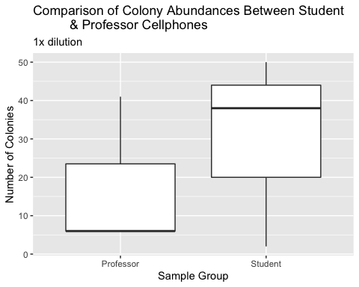

**Figure 1:** Boxplot of colony abundances from Professor and Student cellphones, 1x dilution. Despite a higher median number of colonies from student samples, the mean values were not significantly different between the two sites (Wilcox p = 1).

|  |  |  |  |
| --- | --- | --- | --- |
| statistic | p.value | method | alternative |
| 4 | 1 | Wilcoxon rank sum test with continuity correction | two.sided |
| **Table 4:** | Shows The | p-value resulting from a statistical test for the n | umber |
| of colonies | found on c | ellphone screens between professors and students |  |

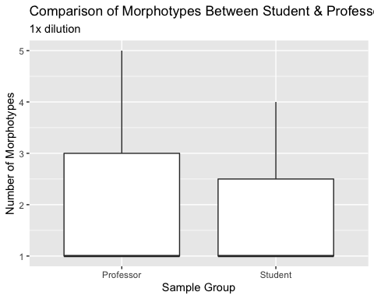

**Figure 2:**Boxplot, made using Mr.Bayes, showing the number of morphotypes from student cellphones compared to professor cellphones. There was no difference in the mean number of morphotypes (Wilcox p=1).

|  |  |  |  |
| --- | --- | --- | --- |
| statistic | p.value | method | alternative |
| 5 | 1 | Wilcoxon rank sum test with continuity correction | two.sided |
| **Table 5:** | Table sho | ws p-value as a result from a statistical test for t | he |
| number of mo | rphotypes | found between professor and student cellphones |  |

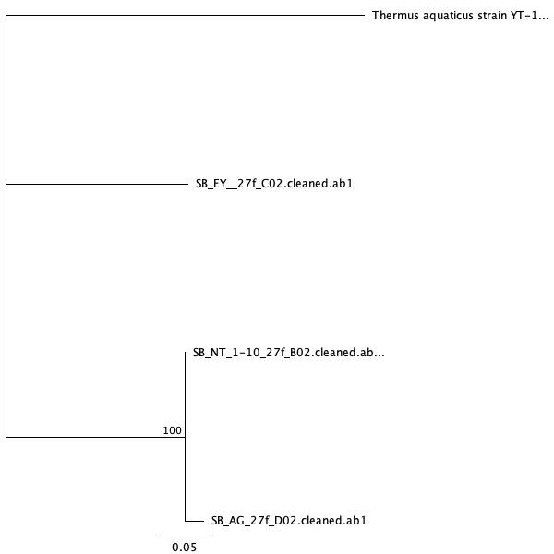 **Figure 3:** This figure shows the PhyML phylogeny for Taq and its relationship to the bacteria found on the sample cellphones.

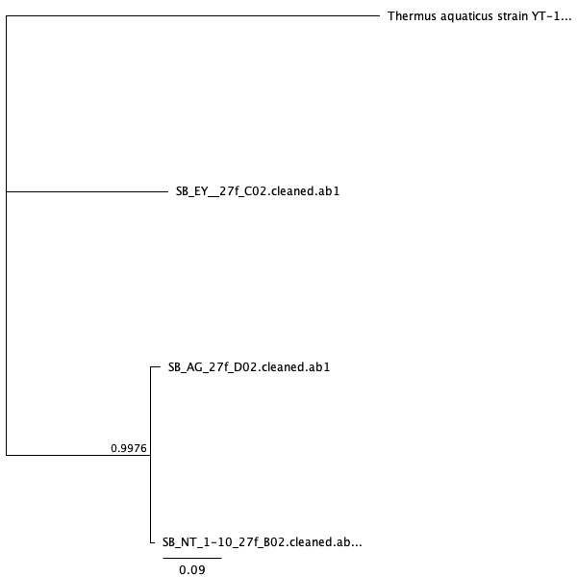 **Figure 4:** This figure shows the Mr.Bayes phylogeny for Taq and its relationship to the bacteria found on the sample cellphones.

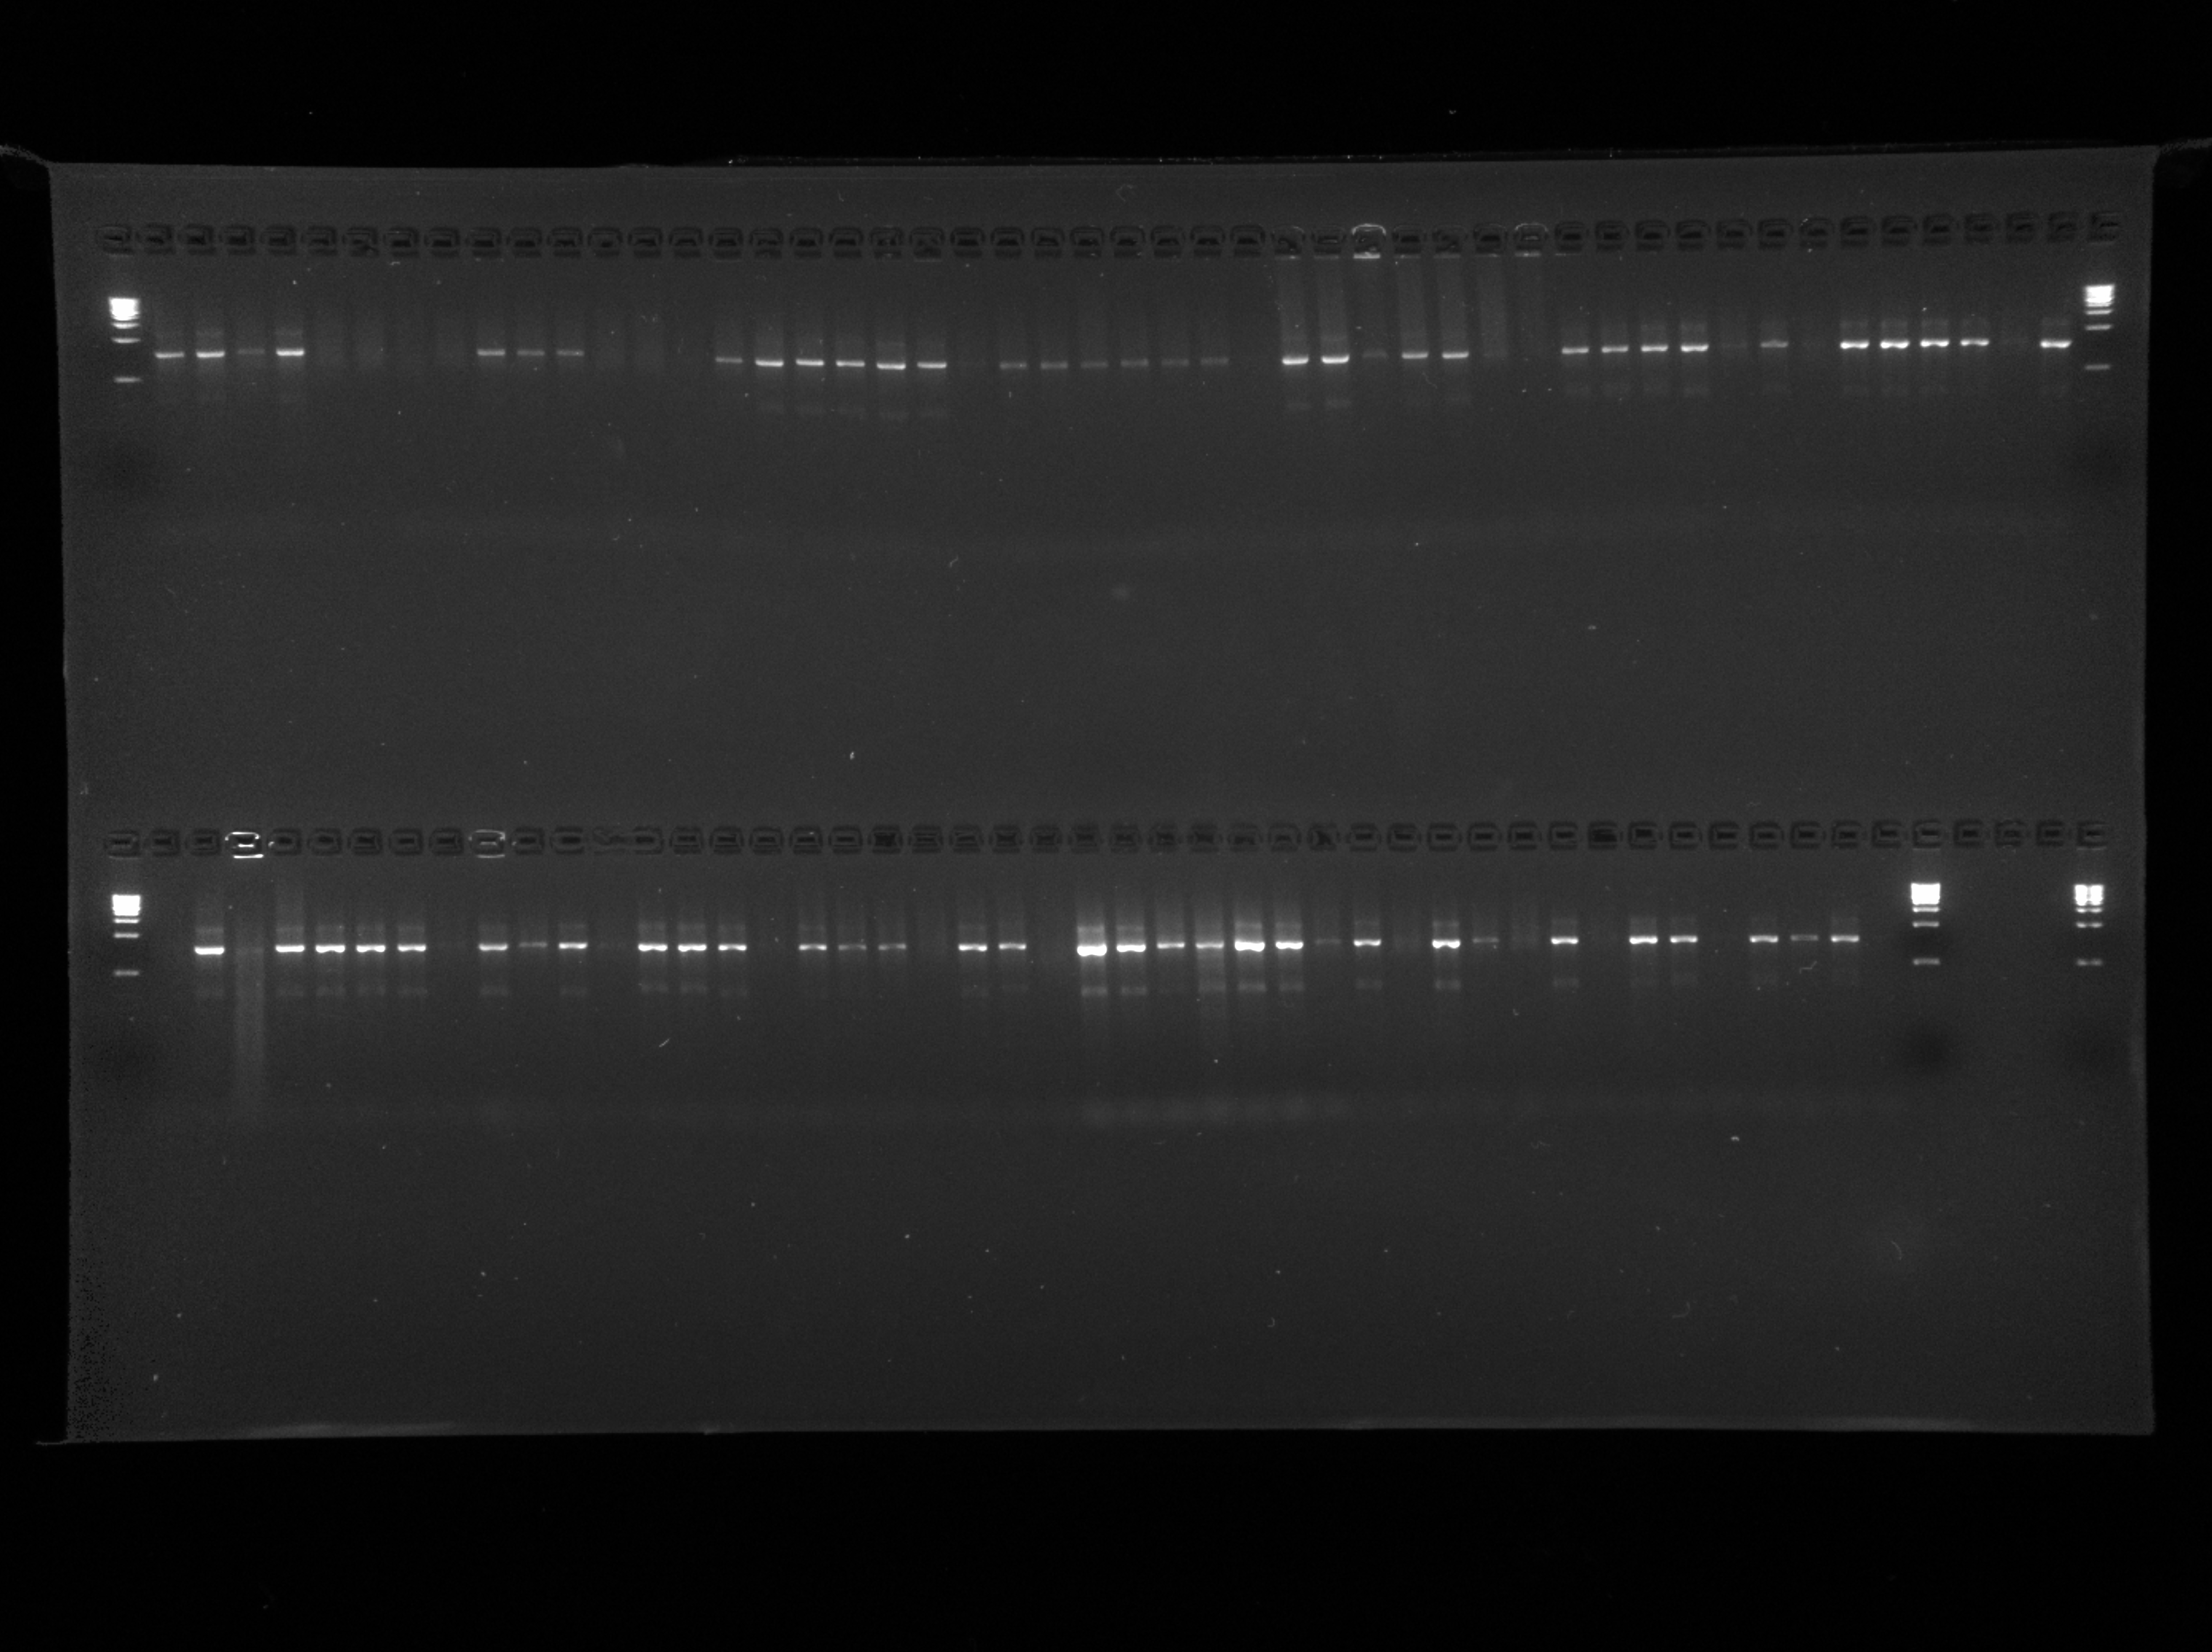 **Figure 5:** Image shows the PCR results. Well 9 was sample “Prof SS 1-10”, well 10 was sample “Prof NT 1-10”, well 11 was sample “Prof EY”, well 12 was sample “AG”, well 13 was sample “SB 1-10”, well 14 was sample “JI”, and well 15 contained a negative control, which was pure water.

# Discussion

The objective of this study was to figure out what strains of bacteria were to be found on cellphones and to also see which sample group had a higher amount of bacteria on their phones. I hypothesized that all cellphones will carry potential pathogens, since a majority of people have their phones every place they go. I also hypthesized that student cellphones will have a significantly higher amount of potential pathogens compared to professor cellphones.

Wells 9, 13, 14, & 15 had no band showing, which could have resulted from pipetting error, using incorrect primers, or just the sample DNA being bound really tightly. Well 10 had a brighter band, and wells 11 and 12 had fainter bands as well. However, since wells 10-12 showed, I can conclude there was a significant amount of DNA present in the wells to perform the PCR and show up in the image (Figure 5).

My results showed that the number of morphotypes on both student and professor cellphones were similar. With the boxplot showing the median value of morphotypes to be 1 for both sample groups, I can conclude that there was not a significant difference in the types of bacteria found on the cellphone screens of both sample groups (Figure 2). In contrast, the colony abundance was significantly greater on student cellphones compared to that of the professors’ cellphones, with the median value for the student group being around 37 colonies and the median value for the professor sample group being around 6 colonies (Figure 1). This shows a huge disparity in the colony abundance between the two groups and therefore, as I had initially hypothesized, shows that student cellphones have a higher amount of bacteria present on their cellphone screens than professors at the University of San Francisco.

The bacteria found using BLAST were *Kocuria palustris*, *Staphylococcus aerus*, and *Staphylococcus epidermis* (Table 2). *Kocuria palustris* is a bacteria that is found in the milk of water deer and reindeer (Kovács *et al.*, 1999). This was a puzzling bacteria to find on the screen of a cellphone, as those animals are not within the vicinity of the school campus, therefore I am not confident that this was identified correctly. However, two types of *Staphylococcus* were also identified to be on the screens of the phones that were swabbed and sampled. The *Staphylococcus aerus* bacteria is frequently found in the upper respiratory tract and on the skin (Lowy, 1998). It is also a known virulent pathogen that is currently the most common cause of infection in hospitalized patients. Furthermore, this bacteria produces several toxins within the body. One type of toxin being cytotoxins that induce proinflammatory changes in mammalian cells which can lead to extensive cell damage and eventual sepsis syndrome (Archer, 1998). The *Staphylococcus epidermis* bacteria is, however, found to not cause disease; but, rather maintain a benign relationship with the host. This bacteria is currently being studied for its role in balancing the epithelial tissue and providing a number of resistance genes (Otto, 2009). Since these two bacterial strains are found most commonly on the skin or within the areas on campus, I am confident that these results were correctly identified. Both the phylogenetic results and BLAST results match up, which also support these findings.

It makes sense that *Staphylococcus* was found on the cellphone screens of both professors and students, since this bacteria is found on the outer layers of the skin. Since a majority of people put their phones up to their ear, potentially pressing the phone against their faces, to place phone calls; as well as using the touchscreen with their hands to navigate through different applications, the *Staphylococcus* bacteria would have ample opportunity to be transferred onto cellphone screens.

With a p-value of 1, I failed to reject the null hypothesis (Table 4). Since I failed to reject the null hypothesis, I can conclude that student cellphones carry more bacteria and, therefore, more potential pathogens, than the cellphones of professors. For the number of morphotypes, I can conclude that, disregarding outliers, 1 was the median number among both sample groups (Figure 2). The resulting p-value was 1 from the statistical test perfomed (Table 5), and given this value, I fail to reject the null hypothesis. Therefore, I can conclude that although students had a higher number of colonies on their cellphones, the number of morphotypes between both sample groups was similar.

My deduction from these findings are that the number of morphotypes are similar because both students and teachers spend a majority of their time in the classroom and/or within similar regions on campus. Therefore, both groups would be exposed to the same bacteria and have an equal likelihood of having the same groups of bacterial strains found on the screens of their cellphones. This is also shown through the study done in a clinical setting which displayed that most nurses and doctors had a similar set of bacteria and viruses found on their phones (Ulger *et al.*, 2009). Although both professors and students had similar bacteria on their cellphone screens, students were found to have had a higher number of bacterial colonies. This is, most likely, due to millenials using their devices more frequently than their teachers. Since students use their cellphones more often, they transfer more bacteria to their devices.

Both phylogenies show support that two samples belonged to the same genus (Figure 3 Bootstap = 100, Figure 4 posterior probability = 0.9976). Since both of the bacterial strains belong to the same genus, it is expected that they would be placed together. However, both phylogenies also show that there is no support that any of the strains belong to the same clade as *Thermus aquaticus*.

# Sources Cited

Akinyemi,K.O. *et al.* (2009) The potential role of mobile phones in the spread of bacterial infections. *The Journal of Infection in Developing Countries*, **3**, 628–632.

Archer,G.L. (1998) Staphylococcus aureus: A well-armed pathogen. *Reviews of Infectious Diseases*, **26**, 1179–1181.

Chawla,K. *et al.* (2009) Bacterial cell phones: Do cell phones carry potential pathogens? *Online Journal of Health and Allied Sciences*, **8**.

Katoh,K. and Standley,D.M. (2013) MAFFT multiple sequence alignment software version 7: Improvements in performance and usability. *Molecular biology and evolution*, **30**, 772–780.

Kearse,M. *et al.* (2012) Geneious basic: An integrated and extendable desktop software platform for the organization and analysis of sequence data. *Bioinformatics*, **28**, 1647–1649.

Korbie,D.J. and Mattick,J.S. (2008) Touchdown pcr for increased specificity and sensitivity in pcr amplification. *Nature protocols*, **3**, 1452.

Kovács,G. *et al.* (1999) Kocuria palustris sp. Nov. And kocuria rhizophila sp. Nov., isolated from the rhizoplane of the narrow-leaved cattail (typha angustifolia). *International Journal of Systematic and Evolutionary Microbiology*, **49**, 167–173.

Kreader,C. *et al.* (2001) One-tube preparation and pce amplification of dna from plant lead tissue with extract-n-amp™. *Molecular Biology Application Notes. Life Science Quartely*, **2**.

Kumar,P. and Aswathy,M. (2014) Identification of mobile phone associated pathogens. *Orthopaedics*, **69**, 72.

Lee,Y.J. *et al.* (2013) Contamination rates between smart cell phones and non-smart cell phones of healthcare workers. *Journal of hospital medicine*, **8**, 144–147.

Leung,K. *et al.* (1995) Survival of $κ$-carrageenan-encapsulated and unencapsulated pseudomonas aeruginosa ug2lr cells in forest soil monitored by polymerase chain reaction and spread plating. *FEMS microbiology ecology*, **16**, 71–82.

Lonkila,M. and Gladarev,B. (2008) Social networks and cellphone use in russia: Local consequences of global communication technology. *New media & society*, **10**, 273–293.

Lowy,F.D. (1998) Staphylococcus aureus infections. *New England journal of medicine*, **339**, 520–532.

Madden,T. (2013) The blast sequence analysis tool. In, *The ncbi handbook [internet]. 2nd edition*. National Center for Biotechnology Information (US).

Masters,B.C. *et al.* (2011) Species delimitation–a geneious plugin for the exploration of species boundaries. *Molecular Ecology Resources*, **11**, 154–157.

Meyer,M. and Kircher,M. (2010) Illumina sequencing library preparation for highly multiplexed target capture and sequencing. *Cold Spring Harbor Protocols*, **2010**, pdb–prot5448.

Otto,M. (2009) Staphylococcus epidermidis—the’accidental’pathogen. *Nature reviews microbiology*, **7**, 555.

Ulger,F. *et al.* (2009) Are we aware how contaminated our mobile phones with nosocomial pathogens? *Annals of clinical microbiology and antimicrobials*, **8**, 7.